LOCATION : NATIONWIDE
DATE : 02.03.2018
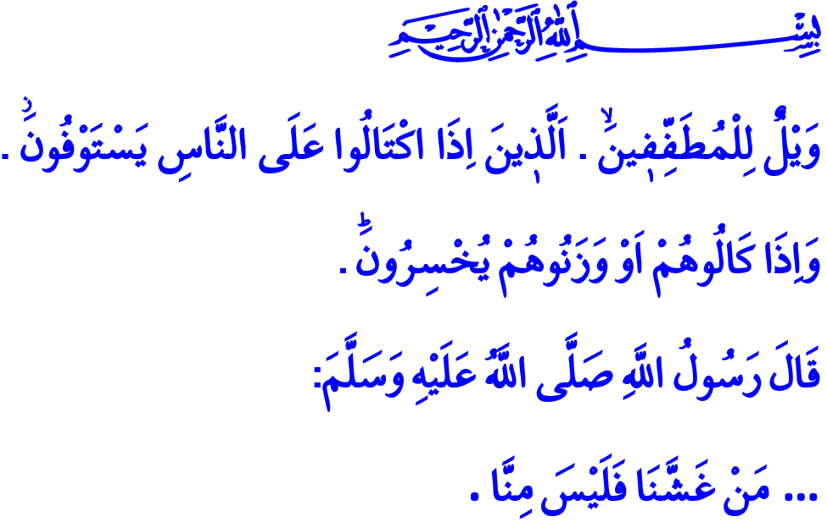
ETHICS OF COMMERCE IN ISLAM
Jumu’ah Mubarak, Dear Brothers and Sisters!
The Messenger of Allah (s.a.w.) occasionally went to the market in Madinah to buy his needs. He watched people shopping and had conversations with them. One day when he was walking around the marketplace, a wheat salesman caught his attention. The wheat pile looked dry but when he stuck his hand in it, he found that the bottom of the sack was not what it appeared to be. The fingers of our Prophet got wet and he asked the salesman why. The man said the wheat got wet by the rain. Therefore, our Prophet (s.a.w.) said, “Then shouldn’t you have put the wet part up for people to see it?” and warned him: “Whoever deceives us is not one of us!”
Honorable Believers!
Our religion deems it essential for a person to live his/her life self-sufficiently and provide sustenance for his/her family. To show an effort to earn one’s sustenance through halal and lawful means and to engage in business and trade is worthy of praise. However, any kind of trade where one does not respect Allah’s countenance, the debt to others and halal-haram sensitivity is forbidden in our religion. Indeed, our Almighty Lord enjoins in the verses I have recited at the beginning: “Woe to those that deal in fraud. Who, when they take a measure from people, take in full. But when they have to give by measure or weight to men, give less than due…”
Brothers and Sisters!
Islam has provided the humanity a roadmap for a peaceful, balanced and righteous life. It has also set some principles for the ethics of trade and commerce. Undoubtedly, the most important principle of the ethics of commerce is earning through halal means. A Muslim not only cares about the earthly profits, but also cares more about the investments made for the Hereafter and about avoiding any haram to stain his/her earnings. S/he does not sell the things Allah Almighty forbids. S/he does not acquire wealth through haram means. S/he avoids ill-gotten gains, interest, black marketeering, abusing public property and tax evasion. S/he would never accept a monopolistic and opportunistic attitude which destroys others and tries to wipe out competitors. S/he does not embrace selfishness, but embraces altruism. S/he acts in accordance with the idea that his/her brothers and sisters should also gain.
Esteemed Muslims!
Another principle of the ethics of commerce is righteousness and honesty. It is being explicit and transparent in trade, and avoiding lies, tricks and deception. In this respect, our Prophet (s.a.w.) said: “The truthful, trustworthy merchant is with the Prophets, the truthful, and the martyrs.”
Being a trustworthy person who speaks the truth is an essential quality of a believer. A believer carries the consciousness of worship in his/her every step while s/he strives to earn halal income. Acting with this consciousness, our ancestors formed the “Ahi-order” tradition and made sure that ethics were respected in bazaars and markets as well as the law. This tradition equipped every craftsman, artisan or merchant with good morals and spirituality besides the professional skills. Throughout history, many communities were influenced by the commercial ethics of Muslim merchants, thus were honored by Islam.
Dear Brothers and Sisters!
Our Prophet (s.a.w.) said: “It is not permissible for a Muslim to sell his brother goods in which there is a defect, without pointing that out to him.” Because hiding the defects of goods destroys the trust of people and takes the blessing out of trade. The seller who conceals the truth ends in defeat, even though he seems to make a profit in the short run. A believer who is aware of this fact does not consider every means allowable for gaining profit, and does not trade temporary earthly goods with eternal bliss in the Hereafter. S/he does not gain profit or interest from the loss of others. S/he does not resort to disrupting the market with deceptive advertising and unfair competition.
Brothers and Sisters!
Another important matter we must pay attention in commerce is that the occupation of trade should not interfere with our duties to Allah as a servant. In fact, our Almighty Lord enjoins: “[Are] men whom neither commerce nor sale distracts from the remembrance of Allah and performance of prayer and giving of zakah. They fear a Day in which the hearts and eyes will [fearfully] turn about.”
Unfortunately, we can see that virtues like sensitivity to halal income, contentment, modesty, honesty and fairness weaken day by day. Greed and avarice, the fondness for wealth and property, luxury and excessive consumption grow like a snowball.
Let’s review our lives to put an end to this situation. Let’s construct our earnings on truth and sincerity. Let’s invest in things that are halal, good and clean. Let’s close the roads to haram, evil and fraud. Let us be believers who earn for the countenance of Allah and spend their income on goodness.

Muslim, Iman, 164; Darimi, Buyu', 10.
Mutaffifin, 83/1-3.
Tirmidhi, Buyu', 4.
Ibn Majah, Tijarat, 45.
Nur, 24/37. Issued by: General Directorate of Religious Services

